Home Page
index.html — General / Site
Quotes….

Shareware tends to combine the worst of commercial software with the worst of free software.
– Linus TorvaldsBy Unknown photographer who sold rights to the picture to linuxmag.com [GFDL or CC-BY-SA-3.0], via Wikimedia Commons

If you, or any public-spirited programmer, wanted to figure out what the software on your machine is really doing, tough luck. It's illegal to reverse engineer the source code of commercial software to find out how it works.
– Clive ThompsonPhoto from Flikr

Free software is software that respects your freedom and the social solidarity of your community. So it's free as in freedom.
– Richard StallmanBy NicoBZH from Saint Etienne - Loire, France [CC BY-SA 2.0 ], via Wikimedia Commons

Proprietary software grew up, starting really in the 1980s, as an alternative and that became the dominant model with the rise of companies like Microsoft and Oracle and the like.
– Tim O'ReillyPhoto (CC) Brian Solis, www.briansolis.com / bub.blicio.us

As the web becomes more and more of a part of our every day lives, it would be a horrible tragedy if it was locked up inside of companies and proprietary software.
– Matt MullenwegPhoto Wikipedia
Proprietary software keeps users divided and helpless. Divided because each user is forbidden to redistribute it to others, and helpless because the users can't change it since they don't have the source code. They can't study what it really does. So the proprietary program is a system of unjust power.
– Richard StallmanBy NicoBZH from Saint Etienne - Loire, France [CC BY-SA 2.0 ], via Wikimedia Commons

A lot of people who work on open-source software don't mind making money elsewhere. They aren't anticommercial.
– Jimmy WalesBy VGrigas (WMF) [CC BY-SA 3.0 ], from Wikimedia Commons
I think, fundamentally, open source does tend to be more stable software. It's the right way to do things.
– Linus TorvaldsBy Unknown photographer who sold rights to the picture to linuxmag.com [GFDL or CC-BY-SA-3.0], via Wikimedia Commons

Open source production has shown us that world-class software, like Linux and Mozilla, can be created with neither the bureaucratic structure of the firm nor the incentives of the marketplace as we've known them.
– Howard RheingoldBy Joi [CC BY 2.0 ], via Wikimedia Commons

The Internet browser is the most susceptible to viruses. The browser is naive about downloading and executing software. Google is trying to help by releasing the Chrome browser as open source.
– Vint Cerf Photo: The Royal Society [CC BY-SA 3.0 or CC BY-SA 4.0], from Wikimedia Commons

Our philosophy is to provide software for our machines free or at minimal cost.
– Apple - in 1976. Apple provides a free OS and free productivity suite, music editor, photo management and video editor with its computers and mobile devices today.

When software is free, or so inexpensive that it's easier to pay for it than to duplicate it, then it won't be "stolen".
– Jim Warren, July 1976Jwarren36 at English Wikipedia [GFDL or CC BY-SA 3.0 ], via Wikimedia Commons

…most of you steal your software. Hardware must be paid for, but software is something to share. Who cares if the people who worked on it get paid?
– Louis V. Gerstner, Jr.By Kenneth C. Zirkel [CC BY-SA 3.0 ], from Wikimedia Commons

What we believe is going to be very important is the delivery of traditional software and services and hardware over the Net. That's a form of electronic marketplace.
– Bill Gates Photo by DFID - UK Department for International Development (https://www.flickr.com/photos/dfid/14590135480/) [CC BY 2.0], via Wikimedia Commons
It seems like the web, particularly software as a service, provides ample opportunities for you to flourish economically, completely aligned with the broader open source community.
– Matt MullenwegPhoto Wikipedia

Free open-source software, by its nature, is unlikely to feature secret back doors that lead directly to Langley, Va.
– Evgeny MorozovPhoto from Wikimedia Commons

'Creative Commons' is the self-congratulatory name of a self-congratulatory movement. Somewhat like kibbutz on the Internet, the idea is to write programs - 'free ware' - and distribute them without charge.
– Mark HelprinBy David Shankbone [CC BY 3.0 ], from Wikimedia Commons


Learning Opportunities


The home of the Online, Interactive Textbook
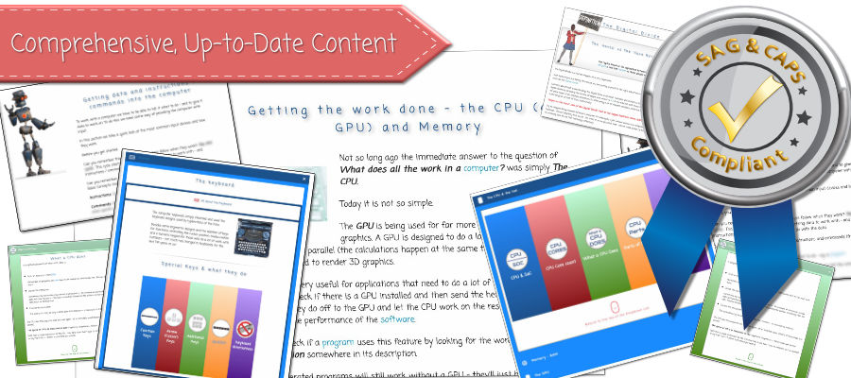
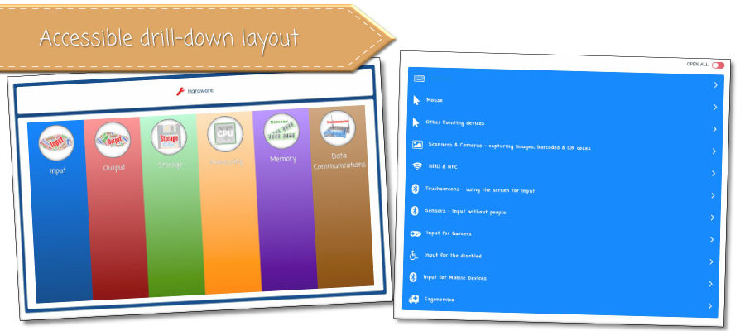
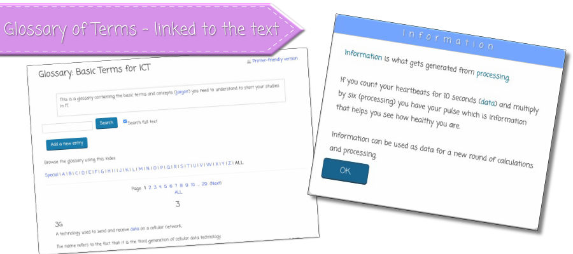
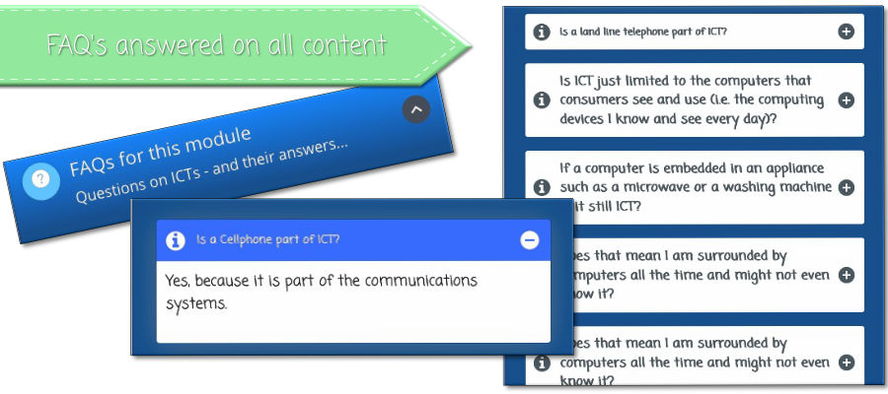
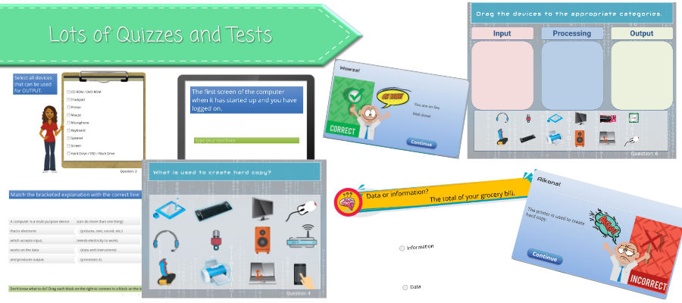
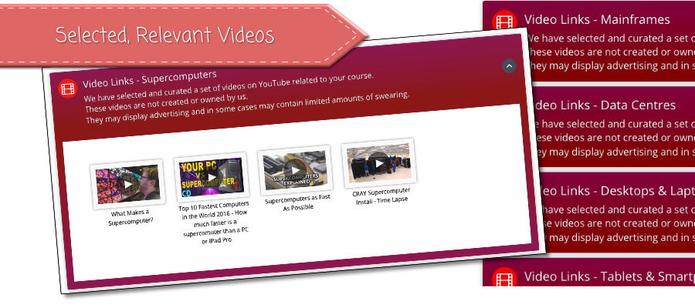

The textbook is the cornerstone of modern learning. The textbook is the place you go to find information that you can rely on - that has been checked to be accurate and relevant (you can not say the same for the information you find on the internet).
The biggest problem with the textbook is that it is a book.
The internet has made us used to interacting with our information and also to finding it as we need it - and finding it in digestable chunks. We often have our digital devices with us. We do not carry our textbooks around with us as often.
Here at Learning Opportunities we believe that it is time the textbook made the move into the internet age. Not in the compromising e-book format but as a truly interactive set of web pages.
So we made it happen - starting with Grade 10 IT Theory…
Now you can not only have your textbook with you any place (or way) that you can access the internet but also find the information you need quickly - and leverage quizzes to maximise your learning!
For Students / Individuals

What you get:
Detailed, up-to date content written in simple, easy to understand language
Drill down structure - makes it easy to find the information you are looking for
Many relevant illustrations
Many interactive quizzes to help you learn (with immediate, detailed feedback)
A large selection of curated YouTube videos (checked to see that the content is relevant and accurate)
Glossary of terms linked to the content.
Interactive lessons
Progress meter - to easily see your progress in the book
Forum - discuss your subject with others using the textbook
24/7 Access across all your devices (best experience is on a tablet / laptop / desktop)
Back to the top of this Panel
For Schools

What you get:
Individual users get all the advantages of our interactive online textbook with its up-to-date content, linked glossary, drill-down structure, illustrations, videos forum, 24 hour access, and quizzes.
Schools can enrol teachers along with learners.
In addition, schools get:
An extra 20% discount for enrolments of 25 learners or more.
A free teacher login for each group of 25 learners.
Back to the top of this Panel
For Teachers

What you get:
A teacher enrolment is only possible as part of a school enrolment of a group of learners.
This is to respect the privacy of learners - the teacher will only be able to monitor extra information for their specific group of learners.
Teachers get all the advantages of our interactive online textbook with its up-to-date content, linked glossary, drill-down structure, illustrations, videos forum, 24 hour access, and quizzes.
Teachers can:
See when each learner logs in, how long they are logged in and which modules they access.
Quickly see visual progress bars for all their learners.
See when each learner takes a quiz - and if the quiz is for marks access the mark attained by the learner.
See each learner's achievements in a markbook which includes all graded activities.
Export marks for their own markbooks.
Back to the top of this Panel
The BEST way to Learn
The heart and soul of learning is your involvement. Learning is not passive. It does not just happen. You have to work at it - you have to DO something.
Reading and watching videos (and we've scoured YouTube for lots of those, making sure that they are relevant to the course) is simply not enough.
Research has proven that the best way to learn is not making notes or summaries or mind maps or highlighting text. None of the traditional ways that you are told to 'study' really helps you to learn the content of your subject.
Many thorough, carefully conducted experiments have shown that the only guaranteed way to learn is to answer questions. To take quizzes.
In fact, you should even take a quiz before you start new work - even if you fail it on your ……! Taking quizzes really does make a difference - especially if you get immediate feedback.
So, to help you learn more effectively we have stuffed many, many quizzes (with immediate feedback) into this online textbook.
Back to the top of this Panel
Pricing

All Learning Opportunities online textbooks are Subscription based - and the subsription runs from the date of your enrolment to the end of the current calendar year (so an earlier enrolment gives the most benefit).
Subscriptions are ZAR 250.00 per user per textbook.
Teacher subscriptions are ZAR 350.00 per teacher.
Schools qualify for a 20% discount on groups of 25 or larger - and each group of 25 qualifies for one free teacher subscription.

Individual learners
Subscribe using the payfast gateway in the Textbook management system (create an account or login and then select the textbook you wish to subscribe to).

Teachers
You can only get teacher access by subscribing through a school along with the group of learners you wish to monitor.

Schools
Send an email to admin@learningopportunities.co.za specifying the number or learner / teacher subscription required. We will send you an invoice and an Excel subscription sheet for you to specify the learner details.
Back to the top of this Panel
Available Textbooks

Information Technolgy

Grade 10
Grade 10 Information Technology Theory
Grade 10 Information Technology Practical (under development, available July 2019)

Grade 11
Grade 10 Information Technology Theory (under development, available January 2020)
Grade 10 Information Technology Practical (under development, available July 2020)

Grade 12
Grade 10 Information Technology Theory (under development, available January 2021)
Grade 10 Information Technology Practical (under development, available July 2021)
Back to the top of this Panel
Who is Learning Opportunities?
Learning Opportunities is the brainchild of Chris Noome - arising from his involvement with Study Opportunities (thanks to Sandra Jacobs for the suggestion of the name).
Chris Noome taught IT from 1991 to 2010. He has served as examiner for both the IEB and the DOE as well as moderator for the IEB. He is one of the Study Opportunities team of authors for their well known and much used series of IT and CAT textbooks (since 1995).
Back to the top of this Panel
Learning Opportunities
Email: admin@learningopportunities.co.za
Phone: +27 83 2866 988
Copyright: © Learning Opportunities / Chris Noome 2018 - 2019

